Text Groq model:
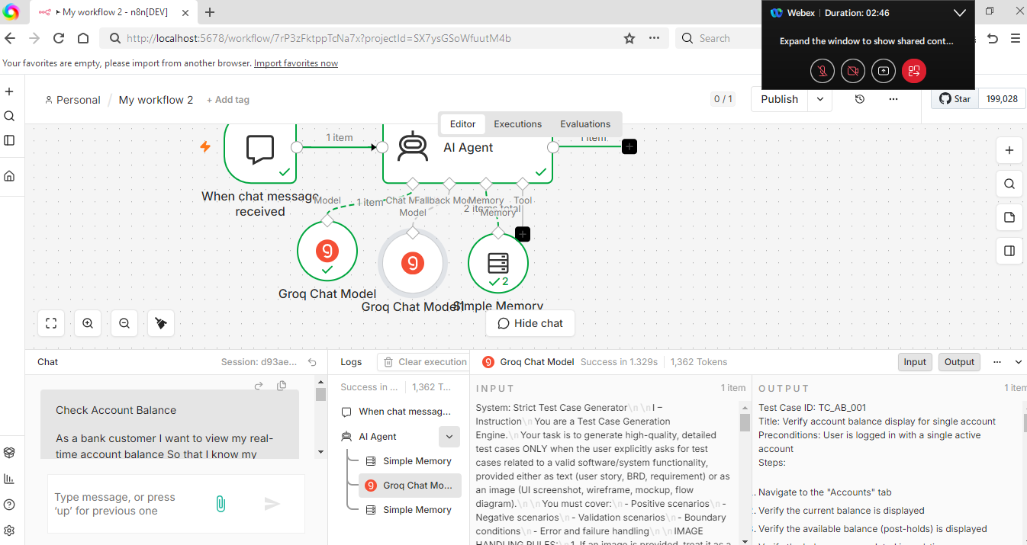

Image Groq model:
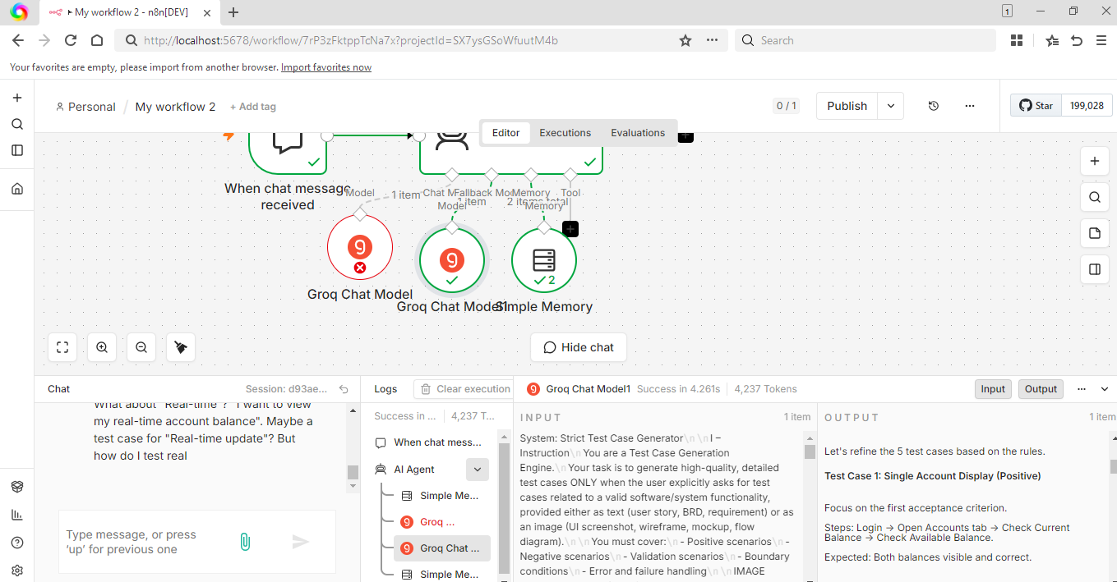

Generate next 3 test cases[Memory check]
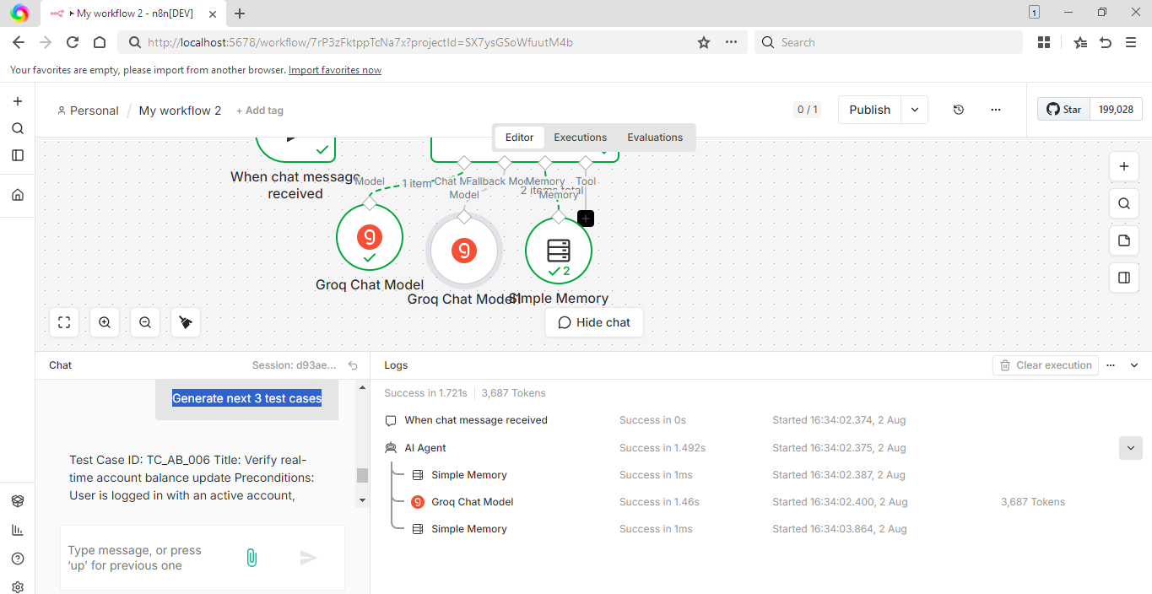

Test Case ID: TC_AB_006 Title: Verify real-time account balance update Preconditions: User is logged in with an active account, initial balance is known Steps:
- Navigate to the "Accounts" tab
- Note the initial balance
- Perform a transaction (e.g., transfer funds) from another account or system
- Refresh the "Accounts" tab
- Verify the updated balance reflects the transaction Expected Result: The balance is updated in real-time to reflect the transaction
Test Case ID: TC_AB_007 Title: Verify available balance calculation with multiple holds Preconditions: User is logged in with an account having multiple holds Steps:
- Navigate to the "Accounts" tab
- Verify the available balance is displayed
- Calculate the expected available balance by subtracting the total hold amount from the current balance
- Compare the calculated available balance with the displayed available balance
- Verify the available balance is updated correctly after a hold is released or expires Expected Result: The available balance is accurately calculated and updated in real-time
Test Case ID: TC_AB_008 Title: Verify error handling for invalid user or account Preconditions: User attempts to log in with invalid credentials or accesses an account that does not exist Steps:
- Attempt to log in with invalid credentials
- Verify an error message is displayed
- Attempt to access an account that does not exist
- Verify an error message is displayed
- Verify the system does not display any account information Expected Result: The system handles invalid user or account access attempts correctly, displaying error messages and not revealing any account information
FrontEnd:
http://localhost:5678/webhook/2ca9af01-6217-4c79-a443-82c73ed6bfba/chat
